Math Lesson 1: Naming Angles
*an angle is formed when 2 lines meet
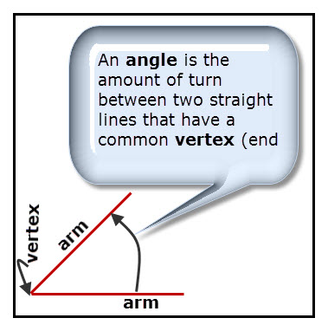
*The angle shows how far one arm is turned to get to the other arm.
*We show an angle is there by drawing a curve from one arm to the other.
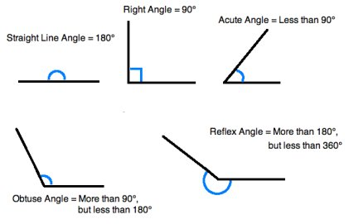
Examples:
Where do you see an acute angle? A right angle? An obtuse angle? A straight angle? A reflex angle?
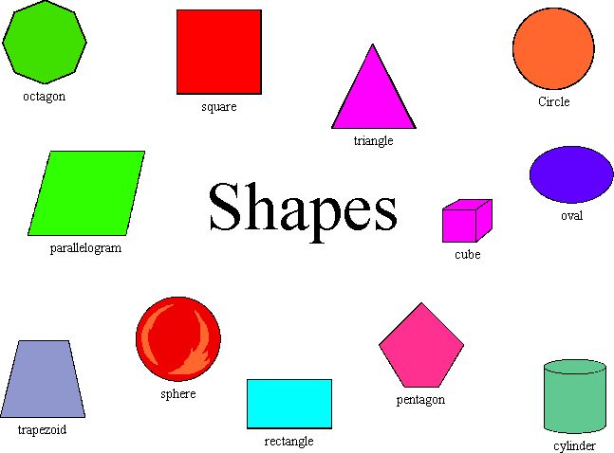


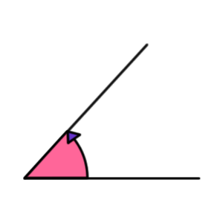
What angles are seen in these clocks?

